South Miami is 2.2 square miles. It has about 13,000 residents.
The proposed zoning covers a bit more than 1 square mile of South Miami. That’s 640⁺ acres.
More than half of that would be zoned at 60 units/acre. 320 x 60 = 19,200⁺ units
The remainder would be zoned at 36 units/acre.
320 x 36 = 11,520 units.

The total would be 30,720⁺ units.

At 2.46 people/household, that would be 75,571⁺ additional residents, or ~ 5.8 times the number currently.
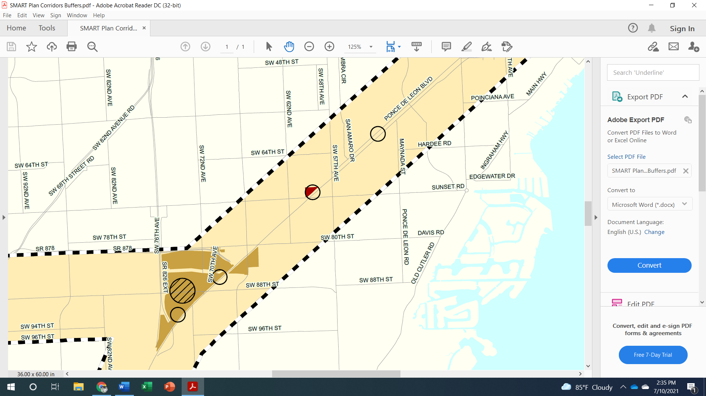
SW 67TH AVE
SUNSET DRIVE
From: Tompkins, Jane <JTompkins@southmiamifl.gov>
Sent: Monday, July 12, 2021 11:23 AM
To: Philips, Sally <SPhilips@southmiamifl.gov>; Shari Kamali <SKamali@southmiamifl.gov>
Subject: RTZ comparison

Good morning,

I was able to use Google Earth to measure the size of different areas of the city that would be impacted by the proposed RTZ, and compare the potential impacts in terms of number of dwelling units and population. My numbers aren’t exact because I used gross acreage, but this is a pretty good comparison, I believe:

Total number of units within ½ mile of Metrorail under the proposed RTZ: 28,528
Total population within ½ mile of Metrorail under the proposed RTZ: 70,175

Versus

Total number of units within ½ mile of Metrorail under City zoning*: 6,770
Total population within ½ mile of Metrorail under City zoning: 16,654
*Based on minimum lot sizes and gross acreage; also, for the Shops and Winn Dixie, I used the number of units approved.

The proposed ordinance also includes standards for properties between ½ mile and 1 miles of the Metrorail, but I haven’t had time to do those calculations.

Regards,

Jane K. Tompkins

Jane K. Tompkins, AICP
Planning and Zoning Director
City of South Miami
6130 Sunset Drive
South Miami, FL 33143
Phone 305.663.6327
www.southmiamifl.gov

By Ms Tompkins’ calculations, a fully built out RTZ would be more than 4 times as dense as South Miami’s current zoning.

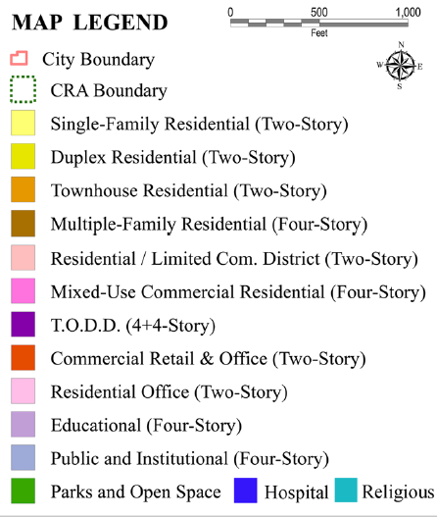
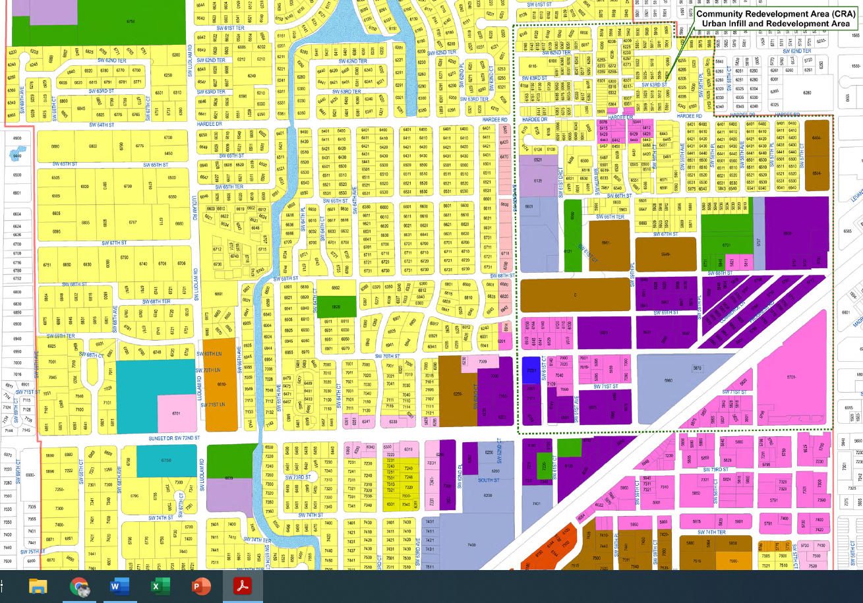
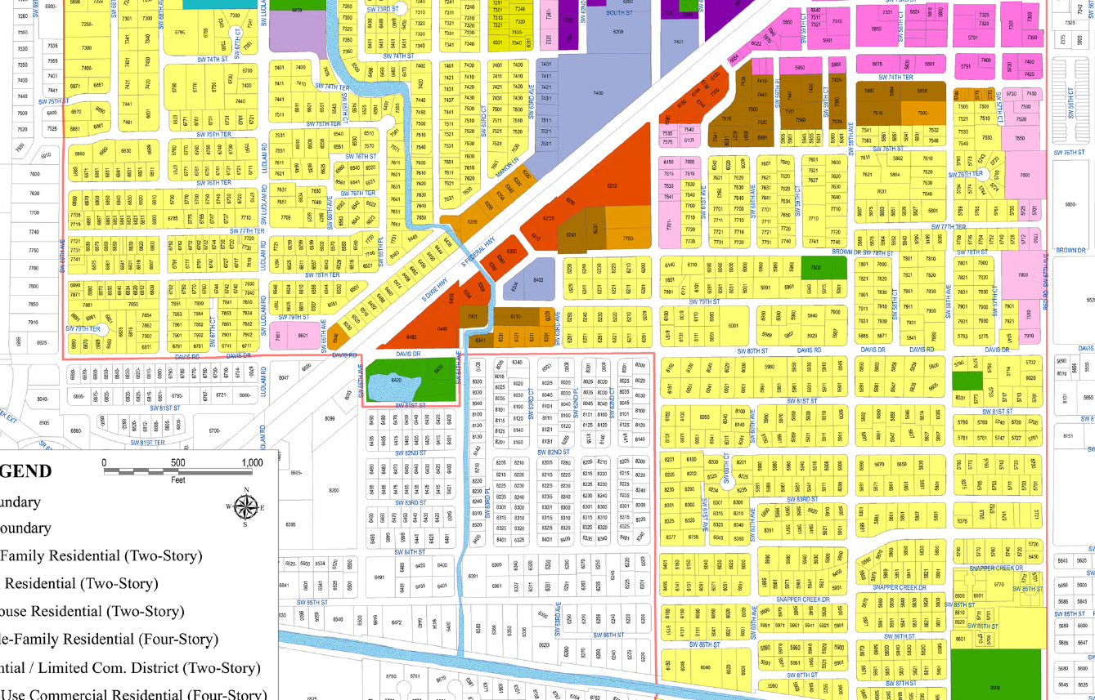
South Miami may be considered a Community Urban Area. If so, at 125 units/acre, fully developed there would be 196,800 (125 x 640 x 2.46) additional residents.

South Miami has already zoned for increased density around its Metrorail station ( ).

