To: The City Commission
South Miami Residents

I have gone through the documents that BusinessFlare, the consultants hired by the City, have prepared about creating a CRA and what that CRA might do.

There is a total of 85 pages. Throughout, the verbiage is glowing about preserving the history of South Miami. However, the consultants describe moving two monuments of this City’s history as if the location of those two are not part of their historical significance. And, as if the process of relocating them will not damage them.

In addition, while they acknowledge that South Miami park acreage (3.5) is below the national average of 10, they fail to mention that moving Jean Willis Park to the Underline decreases that low park acreage.

Attached are segments copied from these documents. Interspersed are my comments about the proposals and the hypocrisy I read. These comments will sound like a diatribe. They are. I have watched developers say one thing and turn around and get permission to do something very different from their original proposals. The gorgeous, welcoming Avalon is my major example of say-one-thing-but-do-something-other.
Whatever happened to the idea of preserving South Miami’s historical features?

The Sylvan Martin building is the only building designated as historical on the west side of US 1. Jean Willis Park is an historical monument in and of itself and in its dedication to an important person in South Miami’s history.

How can a park that is beautifully planted with flowering trees be labeled an “open” space? How can an open space under a racket be proudly labeled “Signature”?

Why even imagine trying to relocate a mature park that is now somewhat insulated from the Metrorail din to a place where its appeal will be destroyed? [See p. 23 of Community Redevelopment Plan. Note that on p. 14 the Park is described as a quiet place.]

There is nothing really restful about sitting in a park under the Metrorail, unless one is deaf. Many people who live within half a mile of the Metrorail know how much the noise of the trains disrupts sidewalk conversations and penetrates yards and homes.

One wonders how any kind of concert, play, lecture, etc., could be appreciated under the cacophony of the overhead trains.

Will all the proposed residential and office units have adequate sound-proof windows and walls?

Why isn’t the Sylva Martin Building mentioned? It is the only building with an historical designation on the west side of the Metrorail. From the looks of the architects’ vision for the City Hall Redevelopment [p. 23], the significance of the Jean Willis Park and the Sylva Martin Building are being ignored. And, in all likelihood, neither of them will survive “relocating.”

Interesting, too, to me, a single cat lady writing a diatribe, is that both these historic sites were named after women who had long careers serving the early City of South Miami. Sylva Martin served as the first woman City Clerk for more than 20 years. She became the City Clerk in the same year that the Sylva Martin building was opened. Jean Willis was on the Commission for 22 years (before term limits were introduced) 1956-1978.

SYLVA MARTIN BUILDING

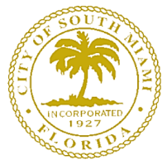
1927 City of South Miami Incorporated
1936 Community Center built
1979 Community Center named for Sylva Martin
https://southmiami.granicus.com/MetaViewer.php?view_id=2&clip_id=849&meta_id=69932
1989 Received Historic Designation
2025 ¿ruined?

“The Sylva Martin Building, located at 6130 Sunset Drive, is the
only historically designated structure owned and maintained by the City of South Miami. Initially built as a Community Center in 1936, the venue has variously served as a meeting place for clubs and fraternal organizations, hurricane shelter, polling place, public library (1958-1977), USO-style entertainment center and community center. Today it houses City administrative offices.”
https://somimag.com/our-historic-architecture-sylva-martin-building/
See also: https://www.library.miami.edu/ohp-south-miami-martin-center.html

“The building received local historic designation on March 17, 1989.”
https://southmiami.granicus.com/MetaViewer.php?view_id=2&clip_id=849&meta_id=69932

“South Miami, incorporated in 1927, is one of the County's oldest municipalities … .”
https://www.southmiamifl.gov/31/Community

In 1936, Mrs. Martin became South Miami's first woman city clerk and served in that capacity for more than 20 years, as well as tax assessor, tax collector and clerk of the municipal court. https://southmiami.granicus.com/MetaViewer.php?view_id=2&clip_id=849&meta_id=69932

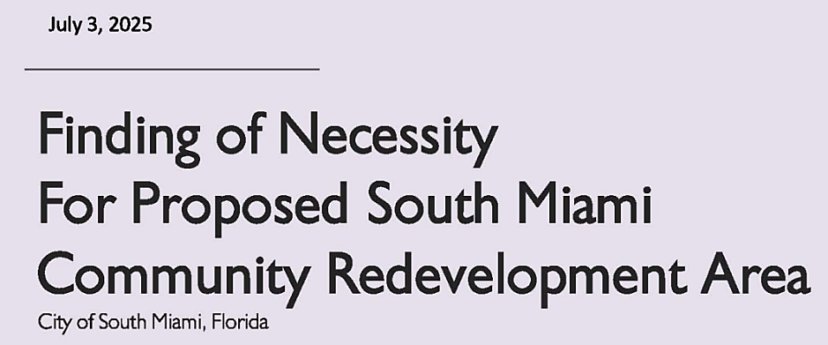

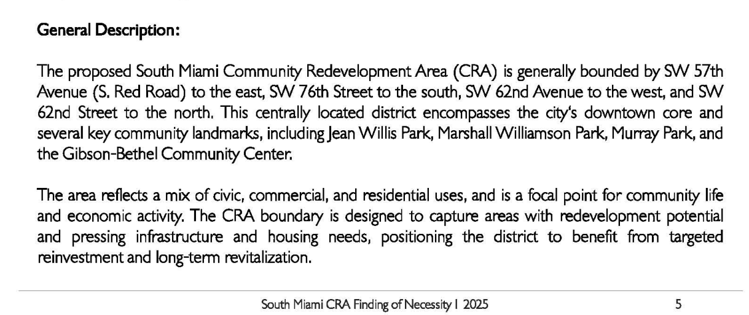

No mention of the Historical landmark: Sylva Martin Building

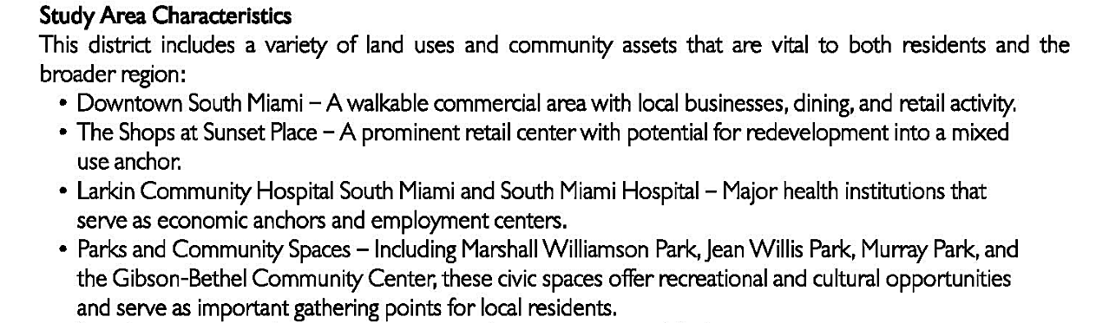

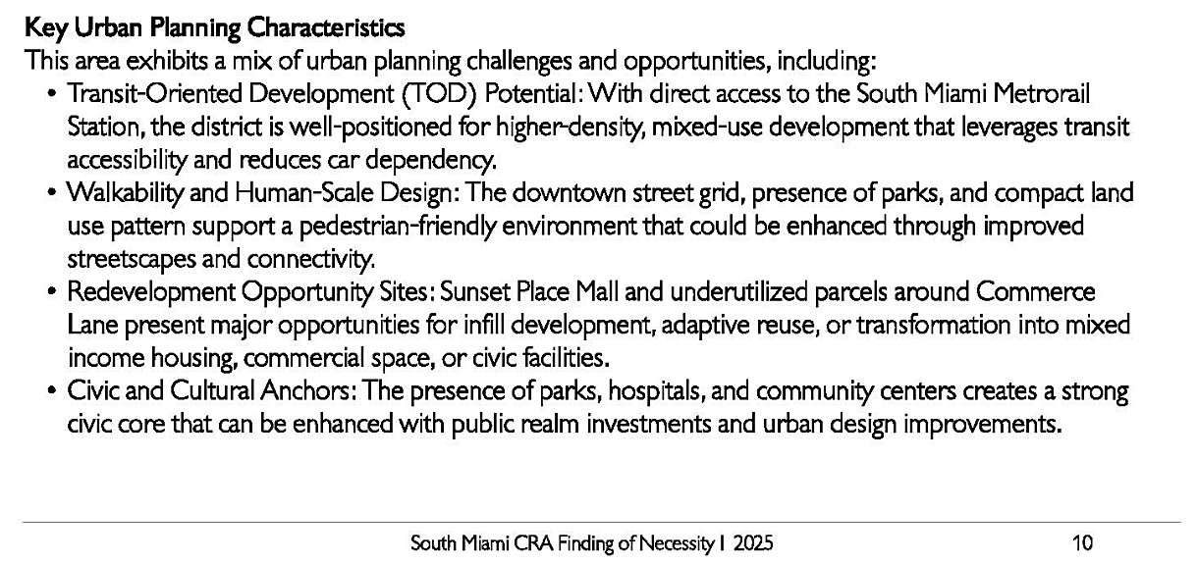
* * *

Repurpose the Sylva Martin Building – open it up as a public meeting venue.

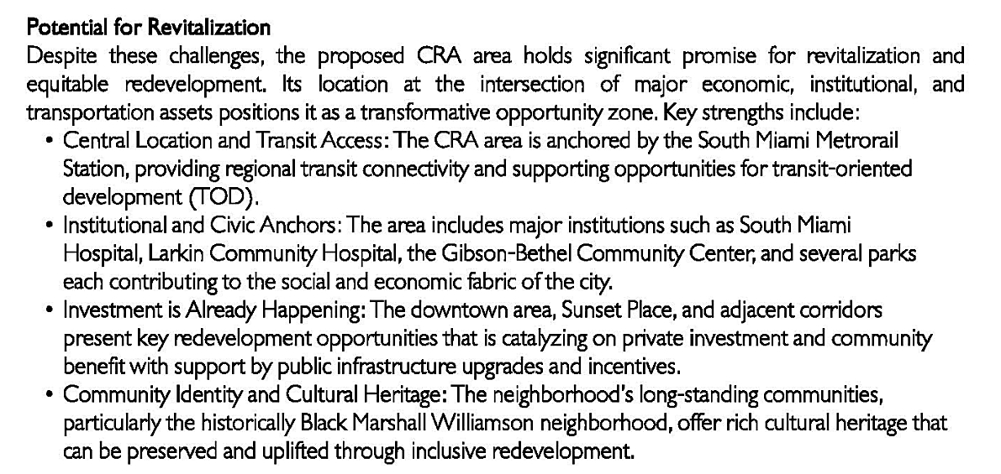

The Sylva Martin Building represents much of the cultural heritage of the City of South Miami. Repurpose it.

Relocating Jean Willis Park to the Underline does NOT increase park acreage. It removes green space by using acreage that would otherwise be considered part of the Underline.

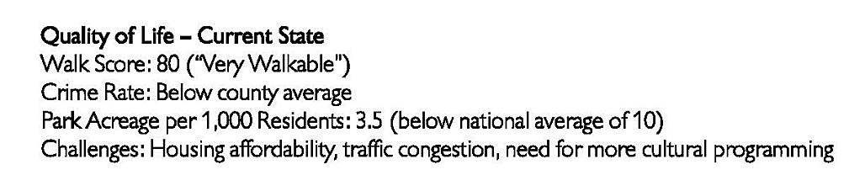

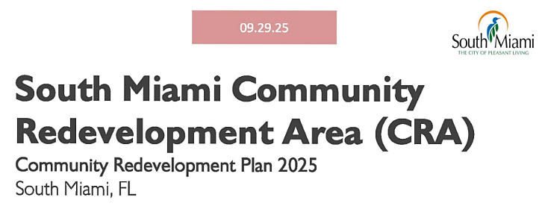

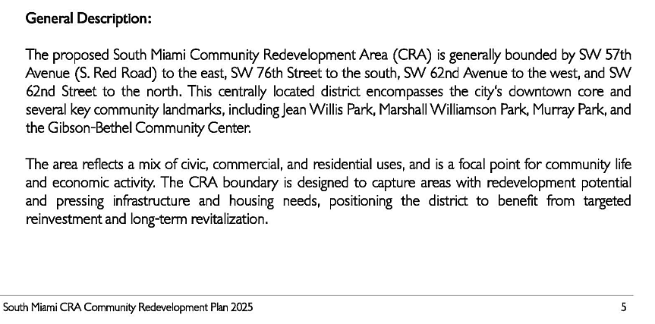

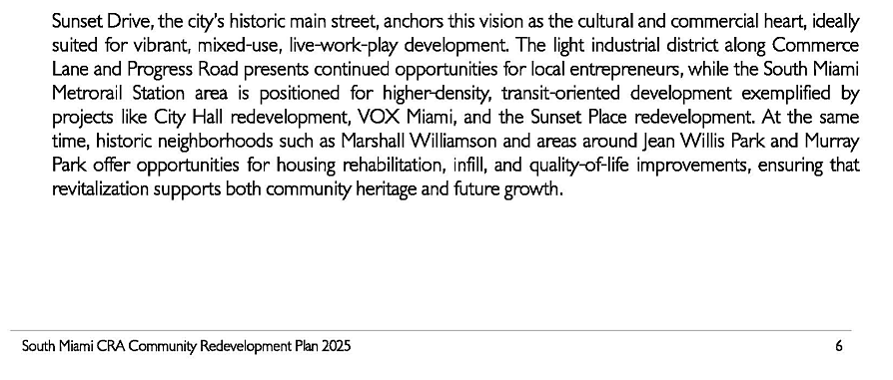
Notice the use of the word around, not in or on.

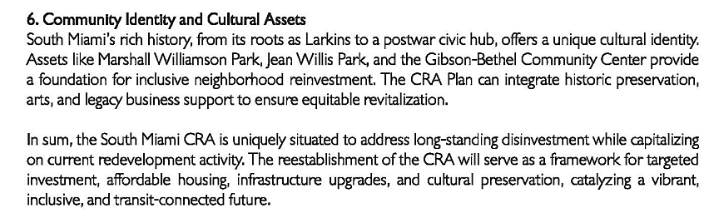

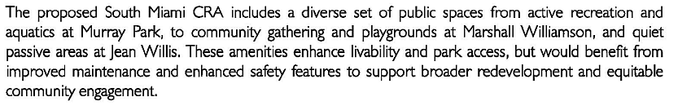

Most of the flowering trees in Jean Willis Park are not natives. They are specimen tropical trees brought from around the world to this location to delight and educate people.

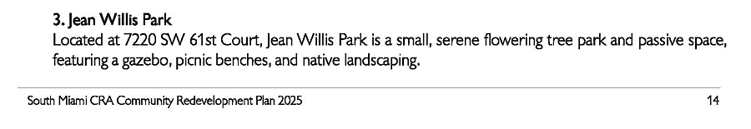
* * *

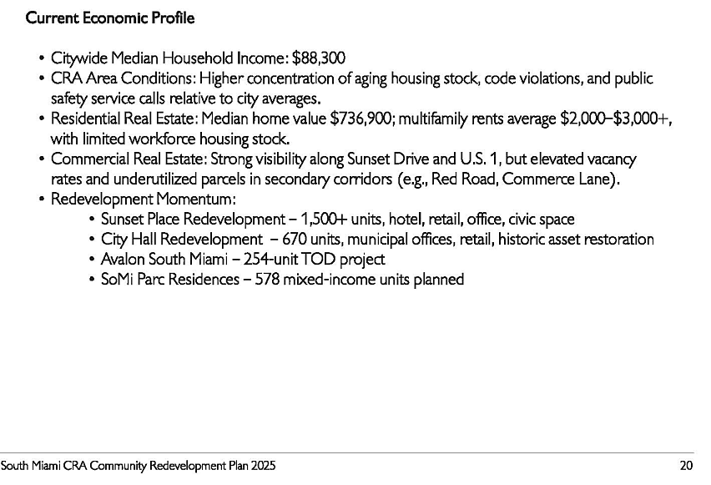

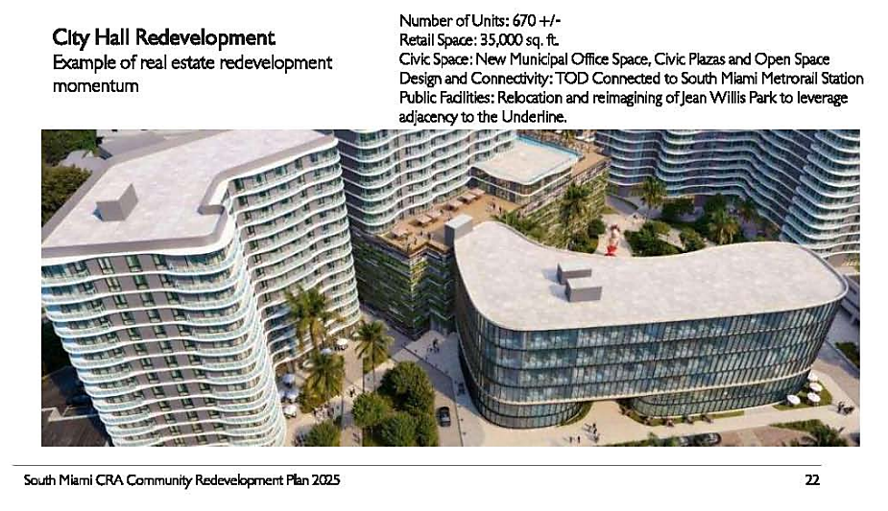

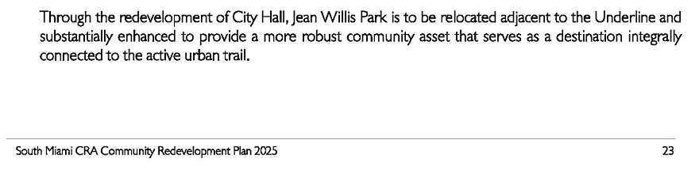

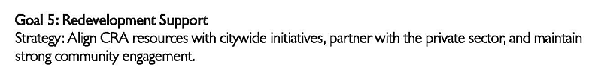

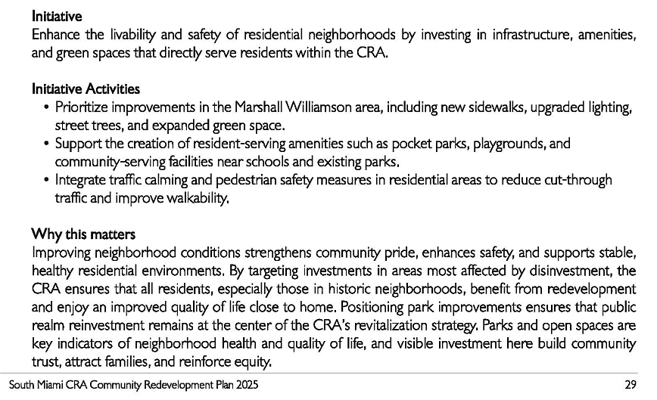

How about a way to walk from Sunset Drive to the Underline down SW 61 Court?

Why, then, ruin two historic City monuments that were named for women who dedicated years to the City of South Miami?

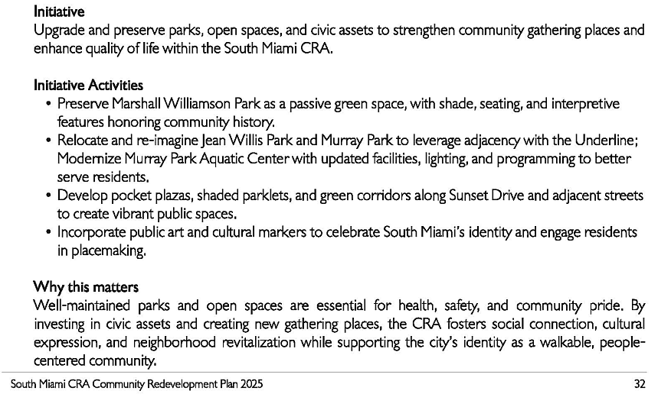

Jean Willis Park can NOT be relocated without ruining the very things that make it special – the
mature, flowering trees. Replacing the existing heritage trees with slender young trees, away
from the Park’s original and historic location - near the Sylva Martin building and somewhat away
from the racket of the Underline – is NOT preservation.

Is not Jean Willis Park just steps from Sunset Drive now?
Why try to re-create what is already flourishing?

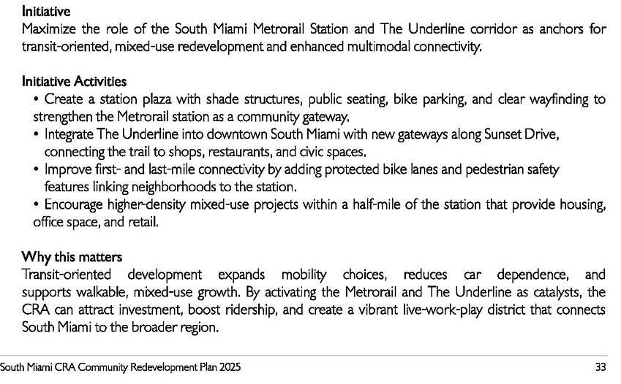
How about a way to walk from Sunset Drive to the Underline down
SW 61 Court past Jean Willis Park?

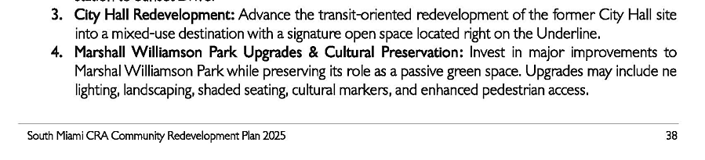

If you are referring to the area that might be labelled Jean Willis Park, how can a park that is planted with flowering trees be labeled an “open” space? How can an open space under a racket be proudly labeled “Signature”?

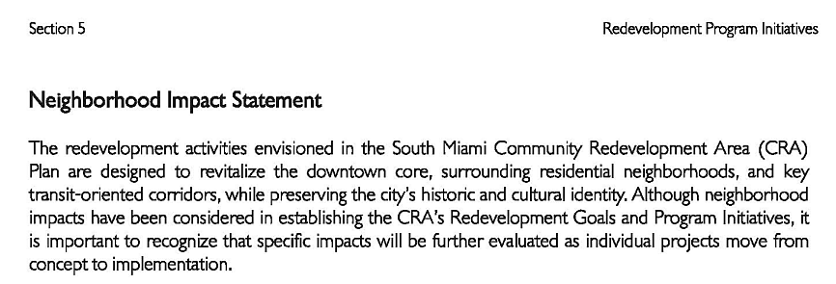

!

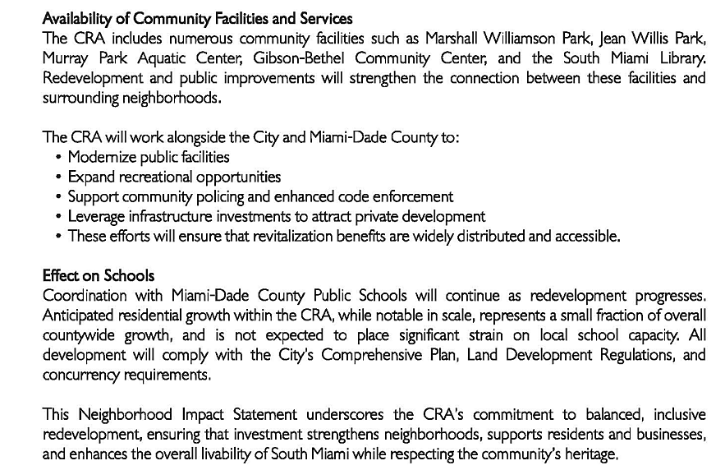

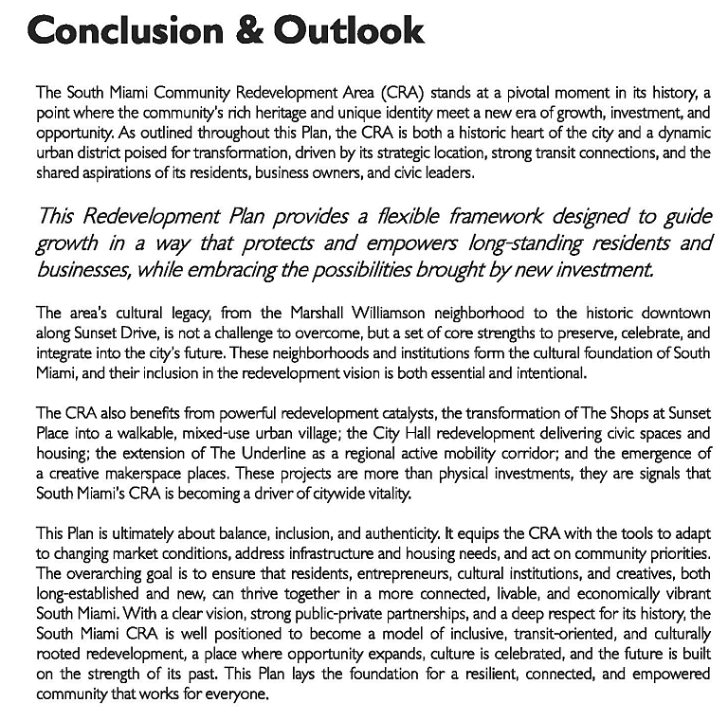

What is authentic about a building built as a community center in the center of the community being repositioned away from its original and historic site to some place where it can only be seen by pedestrians? How does this move respect its history? Moving an 89⁺-year-old coral rock building from its place facing Sunset Drive to somewhere under the Metrorail does not preserve its history and probably will not preserve its structure.

