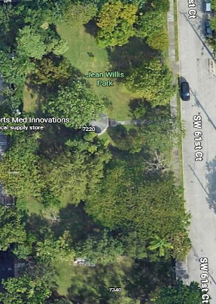
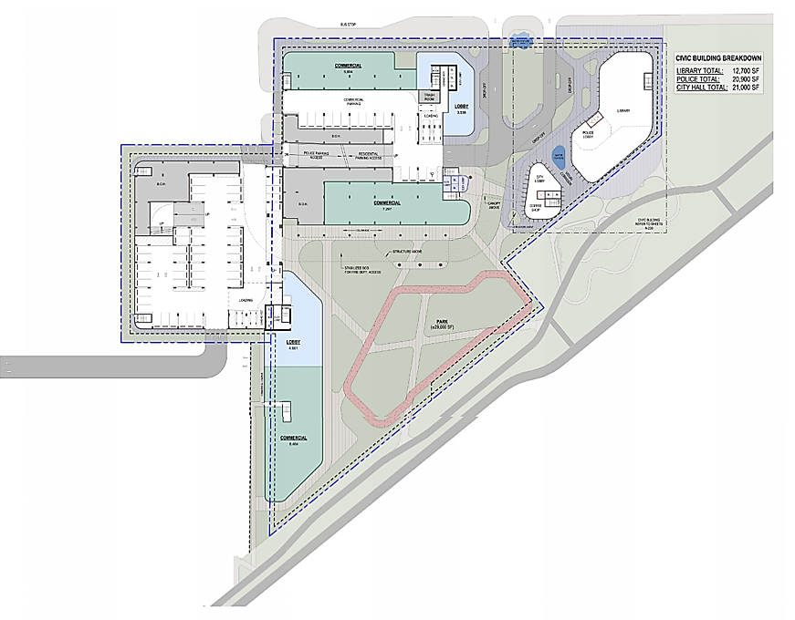
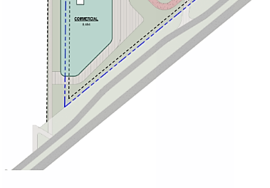

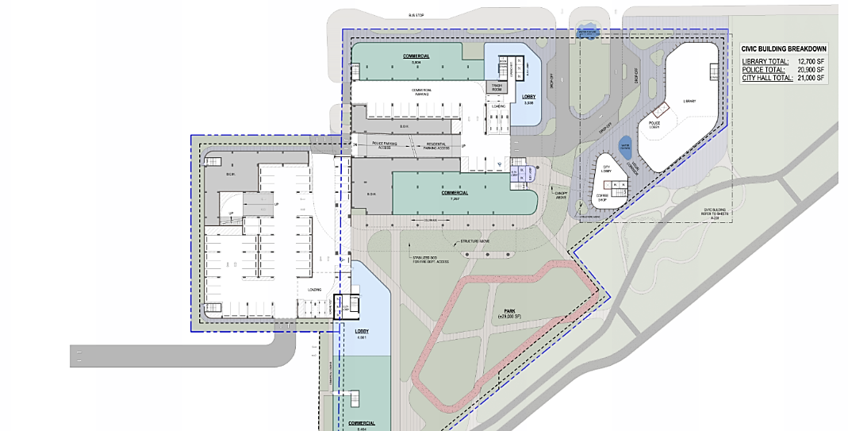
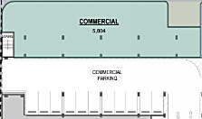
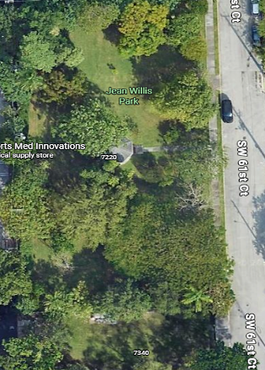
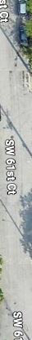
see: https://www.dropbox.com/scl/fi/dvh38ox9h3rh3nstzhmym/25.10.07-Workshop-V3.pdf?rlkey=jyxexlzq0z5u2xhyuvcpeq3xr&dl=0
The Sylva Martin building in place with COMMERCIAL built around it. The City Hall could be built in this COMMERCIAL space around the Sylva Martin building which could be converted to the Commission Chambers.

What it could be:
Jean Willis Park in place as welcome to and recreation for those in apartment buildings and offices.

What kind of quick access do the Police vehicles have from this complex? Looks like they're just as - or even more so - trapped as they are currently.
What about building access for them to US1?
The Proposal from:
Sylvan Martin building

