To: Suramy Cabrera

From: Sally B. Philips

Date: 6 October 2025

About: Jean Willis Park & City Hall Redevelopment Project

Jean Willis Park has been a South Miami landmark since June 1979. It was named for one of the longest (if not the longest) serving South Miami Commission members. Jean H. Willis was on the Commission from 1956 to 1978. In June 1979, the park was dedicated to her, in part, because of her focus on beautifying the City - particularly through landscaping and park development - during her political career.

South Miami Senior High School students constructed a pair of trellises to anchor both ends of the park in 2013. It became the first flowering tree park in Miami-Dade County when, with the City of South Miami’s encouragement, the Tropical Flowering Tree Society (TFTS) restored and replanted the Park in 1992. It is now a Miami-Dade showcase for flowering trees from around the world. There are 49 different species of tropical flowering trees and shrubs, including 5 natives with notable flowers.

Currently, the Park is not particularly busy – perhaps due to the lack of surrounding homes, dedicated parking, and its location on a very quiet street. However, it has been the site of City celebrations and is currently frequented by City employees on their breaks. This lack of use may be the reason the park is not well maintained. Trees need pruning, invasives need removing, and trash needs to be picked up from the ground. [I have picked up soda cans that have been sliced to ribbons by the mowing machines. What mother would let her children run and play in grass filled with cutting edges and cigarette filters?]

In the future, with the building of residences as part the City Hall Redevelopment, there will be an even greater need for and greater utilization of Jean Willis Park. With ever more apartments being built, the City is falling behind in its duty to provide green space.

Moving the Park is impossible. Some of the trees are too mature to survive transplanting. Over 23 trees meet several of the criteria* for being preserved as Heritage Trees. The location of Jean Willis Park is a distinctive part of the park and of South Miami’s history. Were the plans for the Redevelopment to include an inviting connection for pedestrians and bicyclists from the Park to the Underline, Jean Willis Park would become one of the City’s most appreciated spaces.

Stephen D. Pearson has offered – at his own expense – to restore the Park by pruning existing trees and planting additional tropical flowering trees and shrubs. To this end, there is a petition in circulation with about 40 signatures to date. Attached is a copy of the petition’s wording and of Mr. Pearson’s volunteering his expertise and services.

I recommend to the Commission that
- Jean Willis Park be restored to its flowering beauty
- Jean Willis Park be connected to the Underline via SW 61st Court
- Mr. Pearson be invited and encouraged to restore, add to, and maintain the park
- The City remove invasive trees

* Significant Size: Tree worthy of recognition for size
Historically/Culturally Significant: Trees specifically associated with historical dates, events, people, and city landmarks.

from Stephen D. Pearson

Steve Pearson, who participated in the planning and execution of the original planting of flowering trees in Jean Willlis Park and who since then funded and helped lead a partial restoration effort about a decade ago, wants to fund and lead a full restoration of the Park. He is a leader in both the Tropical Flowering Tree Society and TREEmendous Miami ( a group of volunteers dedicated to planting, preserving, and promoting trees in South Florida. He will enlist volunteers to help with the work of restoring the Park by providing needed care of the existing trees, and by proper planting of additional flowering trees and shrubs to restore Jean Willis Park to its former value and beauty.

He would also like to remove the invasive plants that have found homes in the Park. He is willing to do this work, also. However, the most helpful way the City could move this restoration forward is for it to remove the invasives he identifies. Alternatively, if he and the other volunteers do the removal work, then it would be necessary for the City to allow the volunteers to leave the removed materials at the front edge of the Park for disposal by the City.

Mr. Pearson also would like to add small, non-obtrusive signs to identify the trees in the Park. To do so would increase the educational value of the collection. He notes that more people visited the Park after the original flowering trees were planted, and he believes that visitors will come and enjoy the Park more frequently after the proposed restoration takes place. Restoration of the Park would also provide a valuable green space for the occupants of the future apartments being contemplated for the property adjacent to the Park.

Brief overview:

Stephen D. Pearson is a native of Miami who became passionate about trees and their importance to a healthy environment as a young man.
He served as the chair of the City of Miami Committee on Beautification and the Environment
and the Royal Poinciana Fiesta
He is a founding member and past president of the Tropical Flowering Tree Society
founding member and past president of the Friends of Chapman Field
founding member and past president of TREEmendous Miami
former director of the University of Miami's John C. Gifford Arboretum

He served on the board of Fairchild Tropical Botanic Garden for over 20 years
He serves on the board of the Montgomery Botanical Center
Mr. Pearson was selected by the Florida Urban Forestry Council as the state's most outstanding individual
volunteer in 1994 as a result of his leadership and planting of trees
He was awarded American Forests' and the National Urban Forestry Council's national Medal for Citizen Activism in 1995.
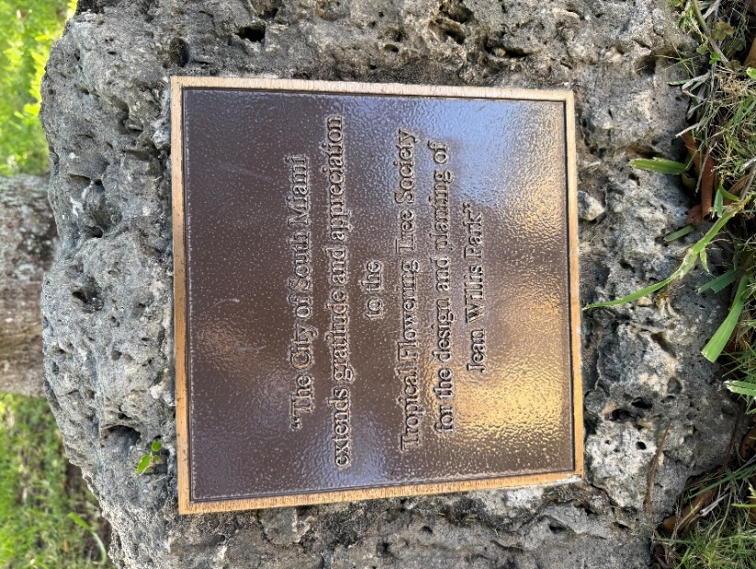
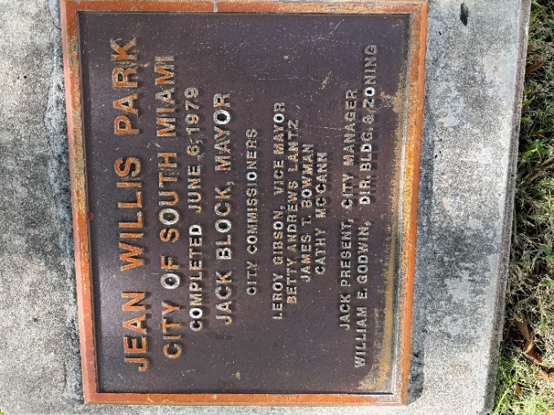
STATEMENT OF SUPPORT FOR JEAN WILLIS PARK IN SOUTH MIAMI

JEAN WILLIS PARK is an important community resource that provides beauty, peace, and education to the public, while helping to provide a healthy environment for humans and fauna in the area. It was the first flowering tree park in Miami-Dade County when, with the City of South Miami’s encouragement, the Tropical Flowering Tree Society (TFTS) restored and replanted the Park in 1992, earning praise and thanks from the City of South Miami, as well as awards and praise from various organizations with a focus on beautification and the environment. TFTS then helped obtain funding and added its own funding to restore the gazebo in 1993, and it has sporadically helped maintain and/or replant the Park over the intervening years.
The undersigned urge the City of South Miami to help remove a few dead or invasive trees presently existing in the Jean Willis Park, and to allow TFTS to restore the Park by maintaining existing trees and planting additional tropical flowering trees and shrubs so as to restore the beauty of the Park created by the plantings of TFTS in 1992. The undersigned further urge the City of South Miami to maintain the Jean Willis Park in its present location in perpetuity as a showcase for tropical flowering trees, and that its destruction or sale should never be considered, including in any sale or redevelopment of the current City Hall and other City structures to the east of the Park, or otherwise.

(About 40 people have signed this support petition so far. More are expected to do so.)

